Azure Resource Manager (ARM) API

1. Create a Web App through Powershell using ARM API Template

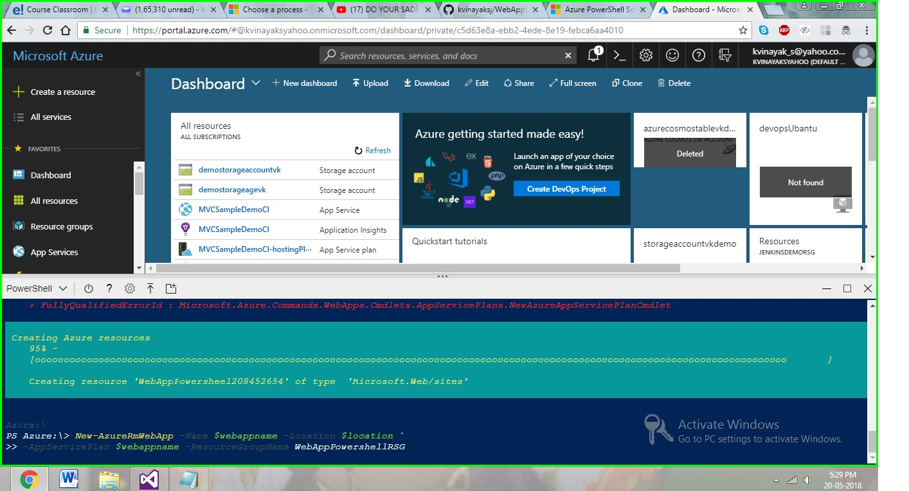

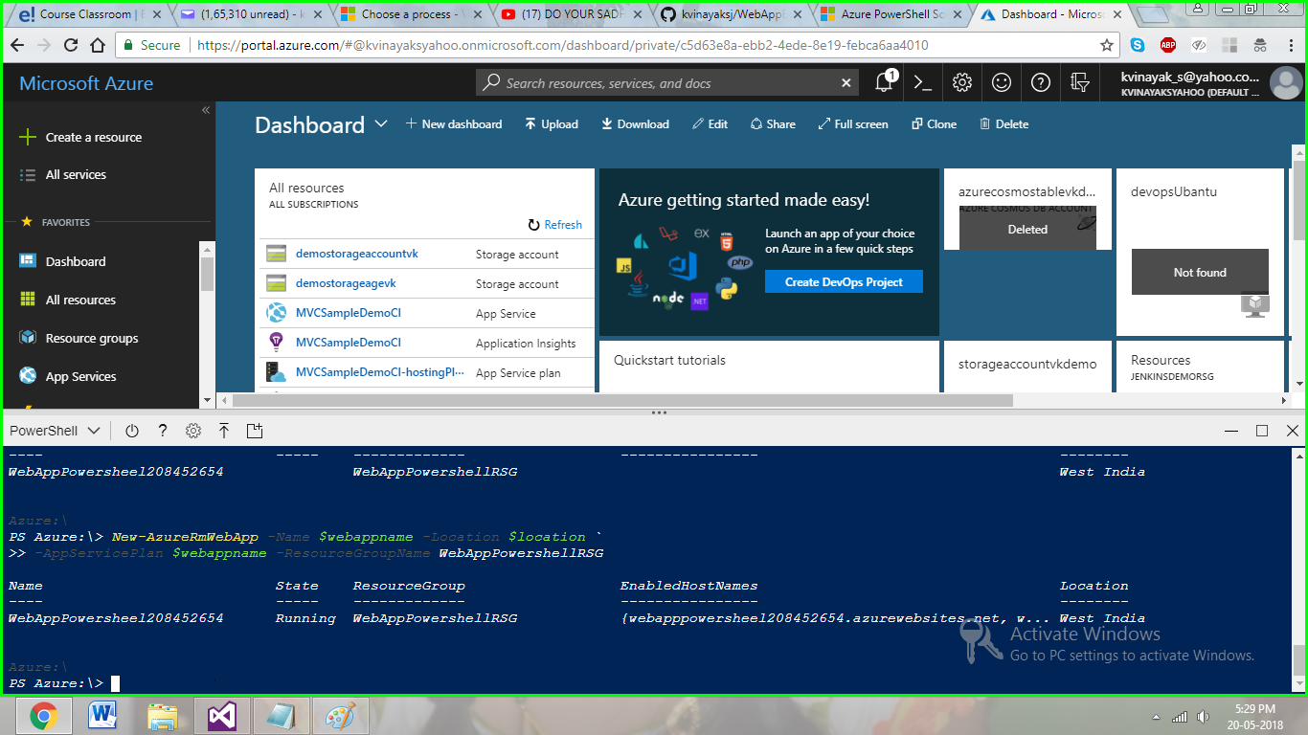

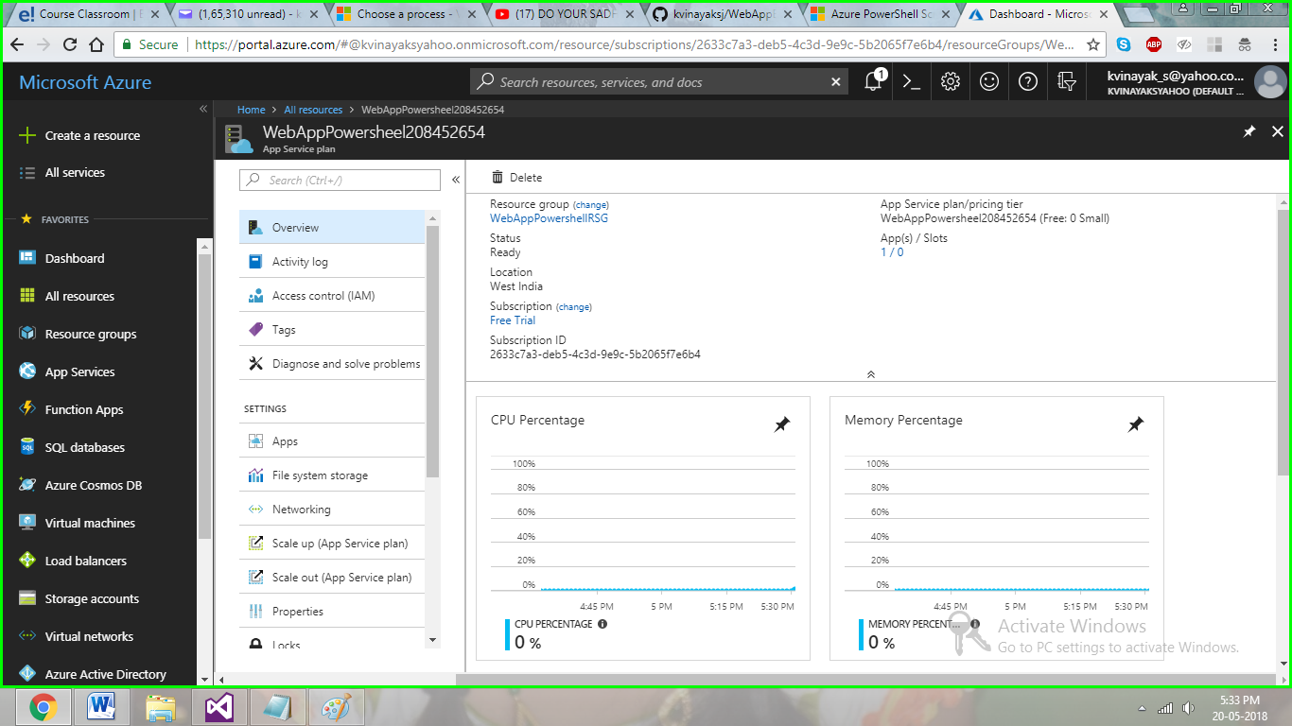

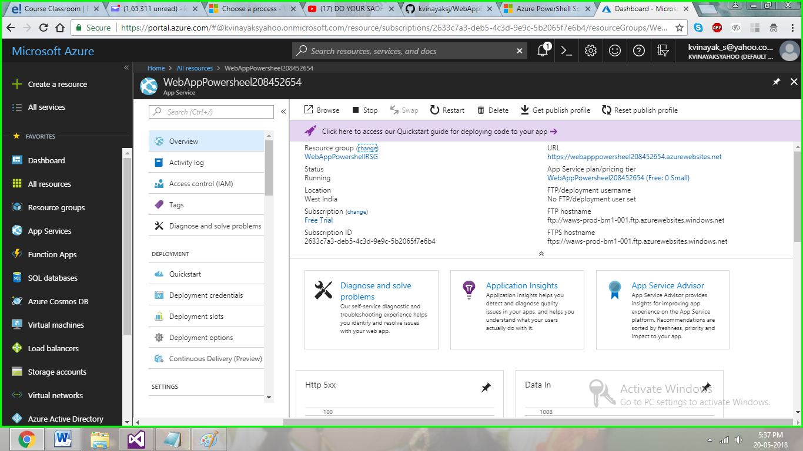

1. Configure CI/CD Pipeline to Deploy an ASP.NET App
2. asa